Power Transmissions

Kayan Patel

Power transmissions transfer mechanical energy from motors to various components of the robot. Power transmission systems are essential in machinery and mechanical devices to transmit mechanical energy from a source (usually a motor or engine) to perform useful work. There are different types of power transmission systems. Some of them are gears, Chains and Sprockets, Belts and Pulleys, Linear Actuators, Worm Gears, and Rack and Pinion. What type of power transmission you use depends on what you are using it for and/or whether you need more speed or torque.

Gears:

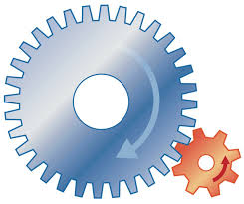Gears come in various sizes and shapes, allowing teams to customize the transmission of power. The gear ratio determines how much speed or torque is transferred. Spur gears are the most common type, but you can also use bevel gears for changing the direction of motion. There are various gear types (spur, bevel, helical, etc.) to suit different applications and requirements. Gears allow for precise control of speed and torque, making them suitable for applications where accuracy is crucial. Gears can be highly efficient.

Chains and Sprockets:

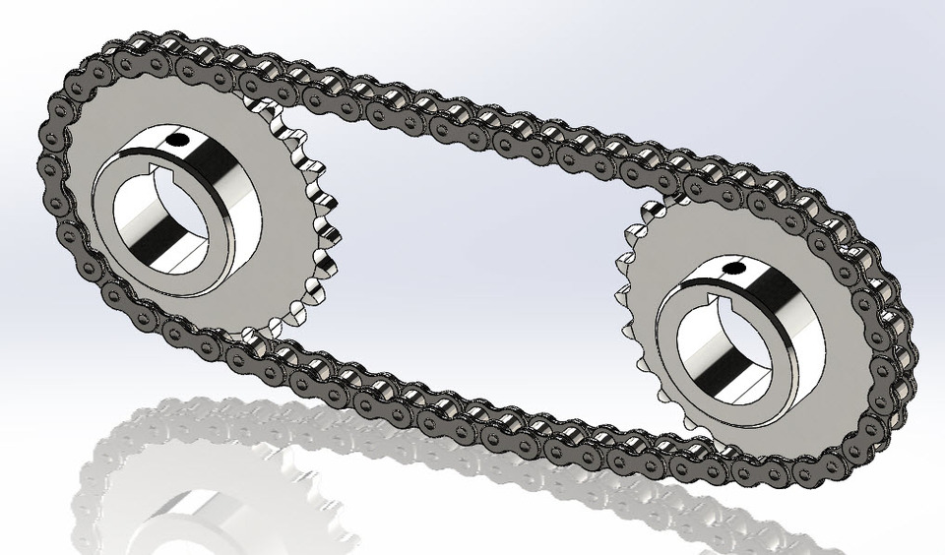Chains can be roller chains, timing chains, or other specialized types. They consist of interconnected links. Sprockets are toothed wheels that engage with chains. They come in various sizes and tooth configurations. Chains and sprockets are excellent for transferring power over longer distances or when you need to transfer power around corners. They are durable and reliable, which is good for connecting motors to wheels or mechanisms. They are commonly used for driving wheels, arm movements, and any application where precise power transfer is needed.

Belts and Pulleys:

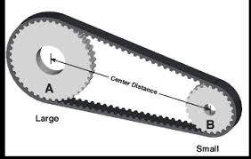Belts and pulleys offer a flexible and lightweight option for power transmission. Belts can be made of rubber or other materials. They come in different profiles and lengths. Pulleys are the wheels over which belts run. They can be flat or grooved. Belts and pulleys are lightweight and can absorb shocks, so they are often used when you want to reduce noise and vibration in the robot. They are mainly used in conveyors, lifting mechanisms, and other situations where flexibility and noise reduction are important.

Linear Actuators:

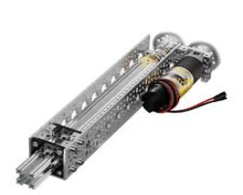Linear actuators can extend or retract, converting rotary motion into linear motion. They are useful for mechanisms that need precise control over position, such as lifting arms or extending claws. Linear actuators provide precise control over linear movement, making them suitable for applications that require accurate positioning. They can offer compact and space-efficient solutions for linear motion requirements.

Worm Gears:

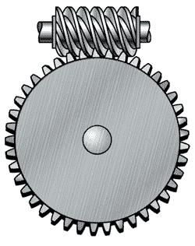Worm gears consist of a worm (a threaded screw) and a gear (the wheel). Worm gears are often used for applications that require high gear reduction and locking in place, such as lifting mechanisms or winches. They are excellent for applications where high torque and self-locking capabilities are needed, preventing back-driving. Worm gears are often used in lifting mechanisms, winches, and applications where holding a position is crucial. They offer stability and holding power, making them suitable for applications that require load-holding capability.

Rack and Pinion:

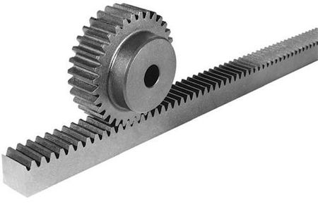In rack and pinion systems, a rotating pinion engages with a toothed rack to convert rotary motion into linear motion. A rotating pinion engages with a toothed rack to move things linearly. These systems are common in linear lifts, slide mechanisms, and steering systems in vehicles. They provide a straightforward way to achieve linear motion. They provide precise linear control and can be used in applications where accuracy is essential.